# جامعة قطر تكشف عن هويتها البصرية الجديدة - جريدة الراية

**GlamGait Shopping Website**

**Spring 2024 – CMPS350**

**Project Report Phase 2**

**Name: Fatima Almohannadi QU ID: 202002315**

**Name: Kholoud Alshafai QU ID: 202001597**

**Name: Reham Alameen QU ID: 201901682**

**Section: L51**

**Submitted to Dr. Mucahid Kutlu**

**Frontend deployment:** [**https://glam-gait-fe.vercel.app/**](https://glam-gait-fe.vercel.app/)

**Backend deployment:** [**https://glam-gait-be.vercel.app/**](https://glam-gait-be.vercel.app/)

**Backend GitHub Link:** <https://github.com/fatima-fa2002315/GlamGait-BE>

* **Data Model:**

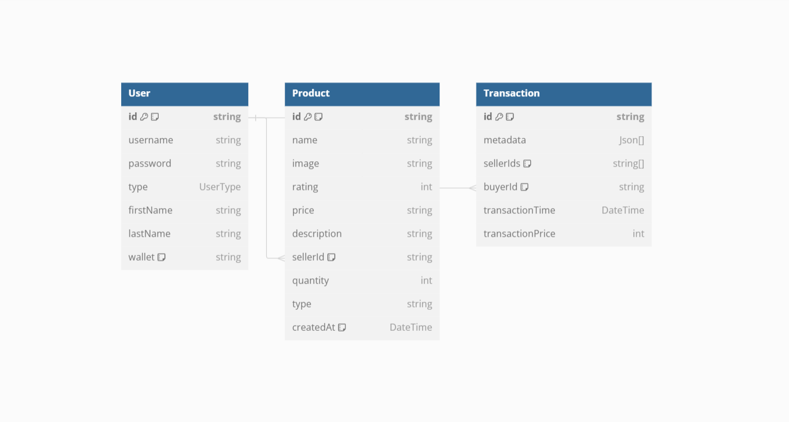

* **Queries:**

1. 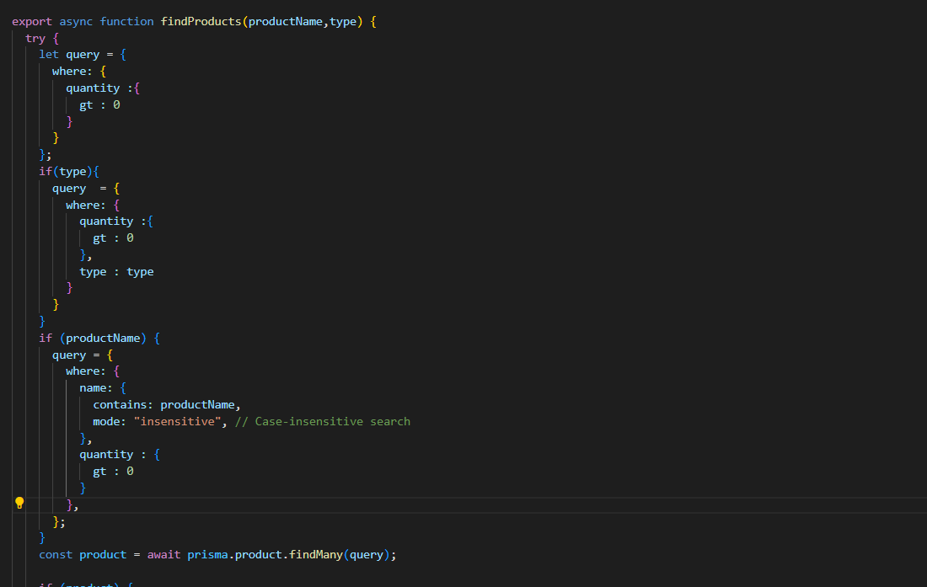**Products**

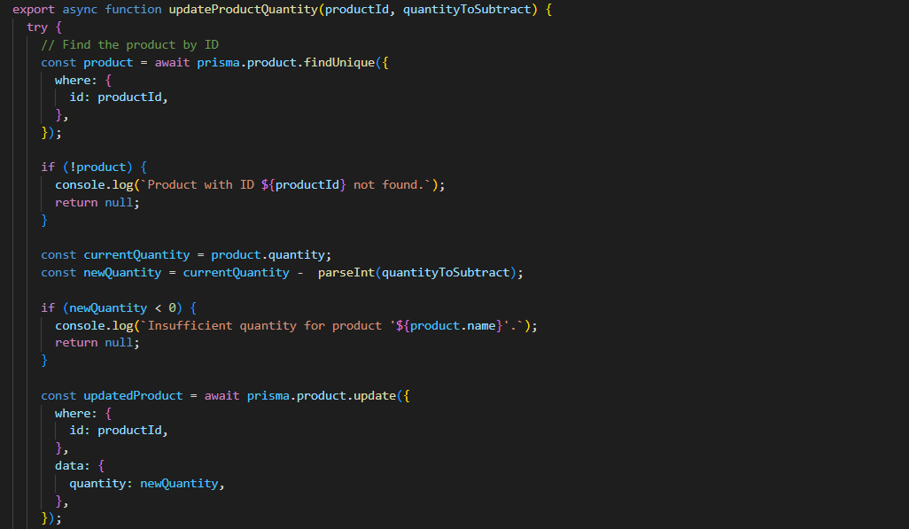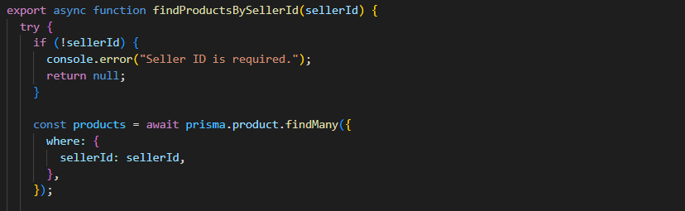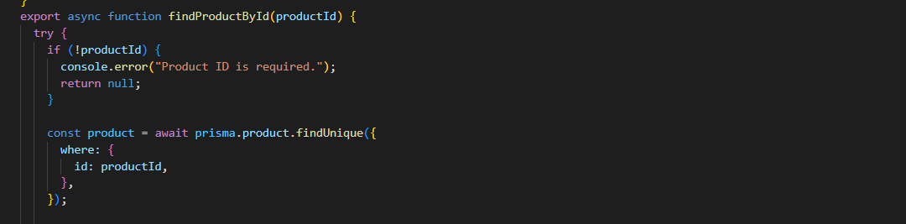

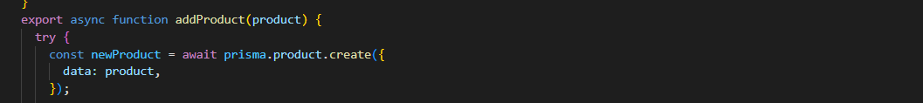

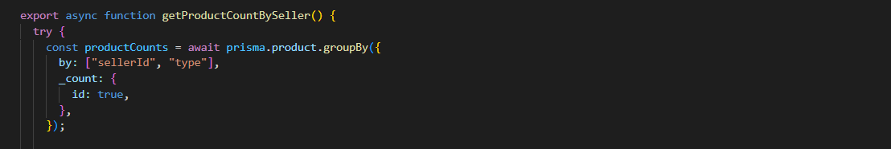

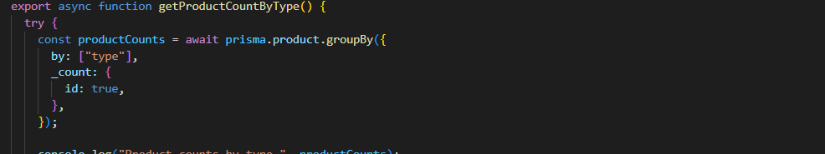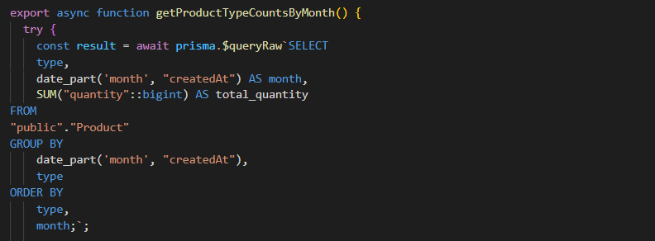

1. **Transactions**

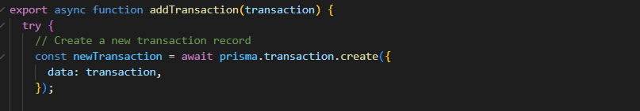

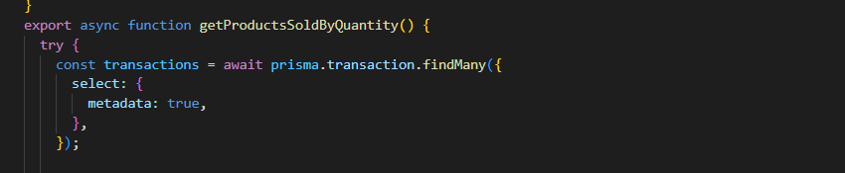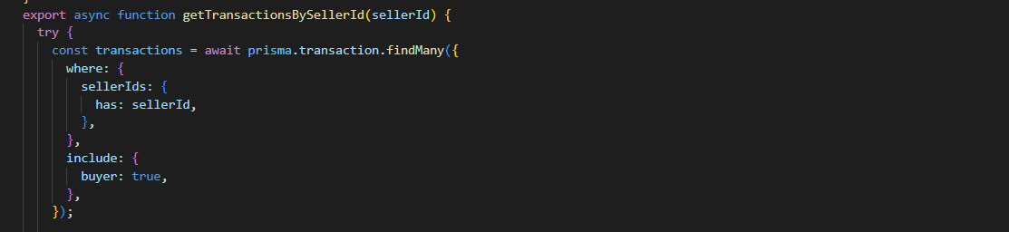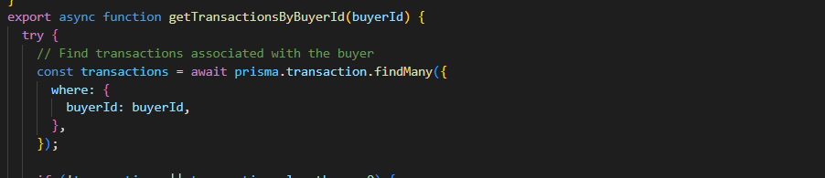

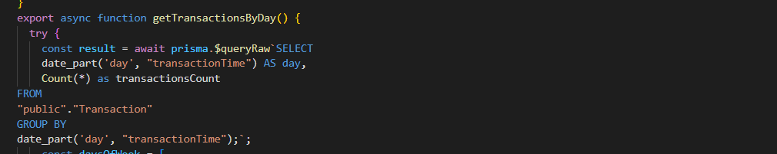

1. 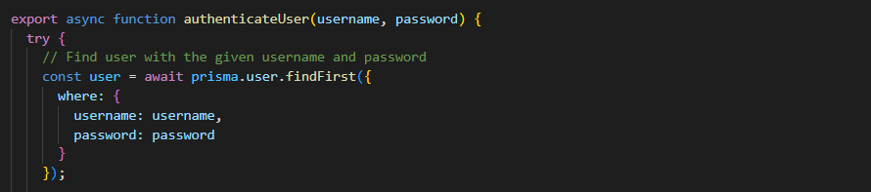**Users**

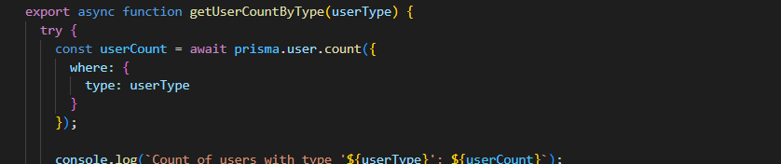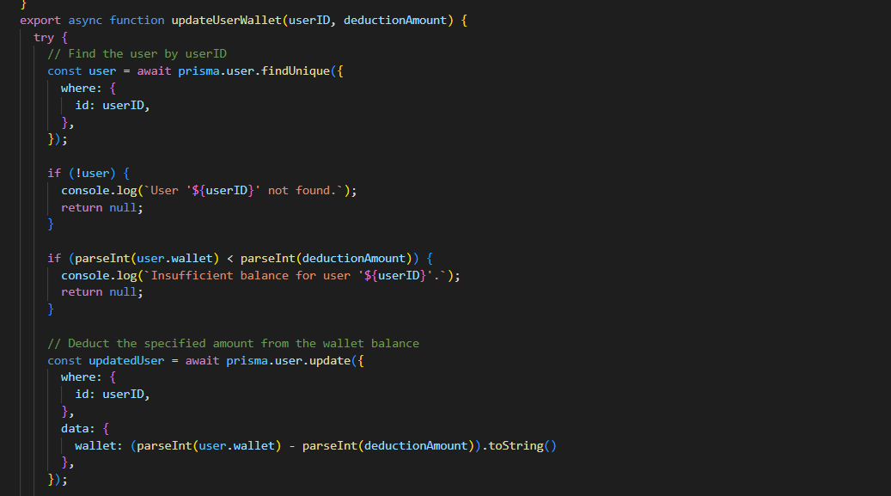

**TEST CASES:**

**Test Case:** Sign In with Valid Credentials

**Objective:** Verify that a user can sign in with valid credentials and is redirected to the appropriate main page based on their user type (seller or buyer).

**Preconditions:**

1. The application is accessible and the sign-in page is displayed.
2. Valid test user accounts exist in the system with defined roles (seller or buyer).

**Test Steps**:

1. Navigate to the application's sign-in page.

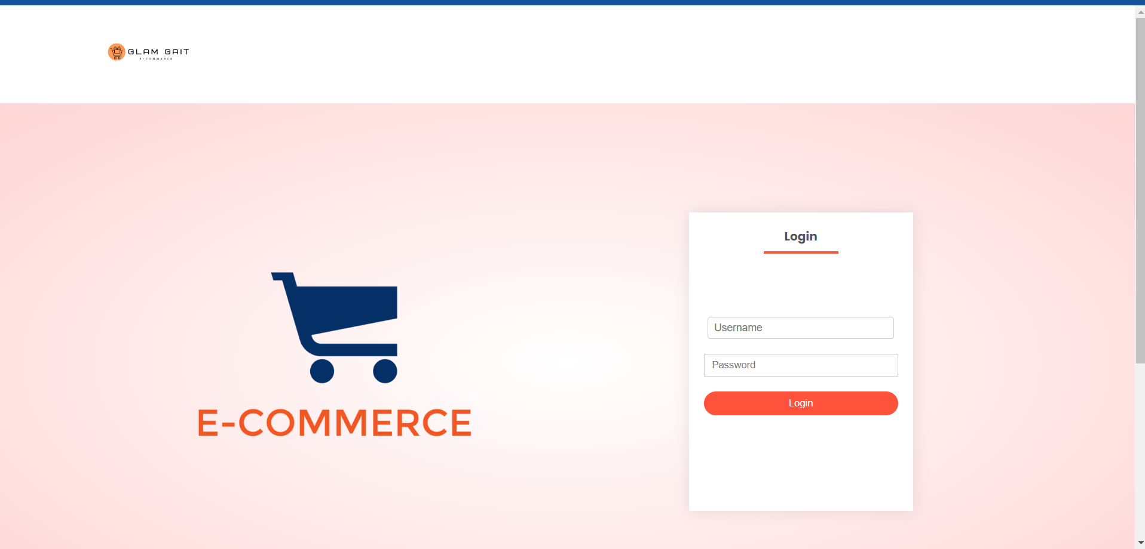

1. Enter valid credentials (username/email and password) of a registered user.
   * Username/Email: [valid username/email]
   * Password: [valid password]

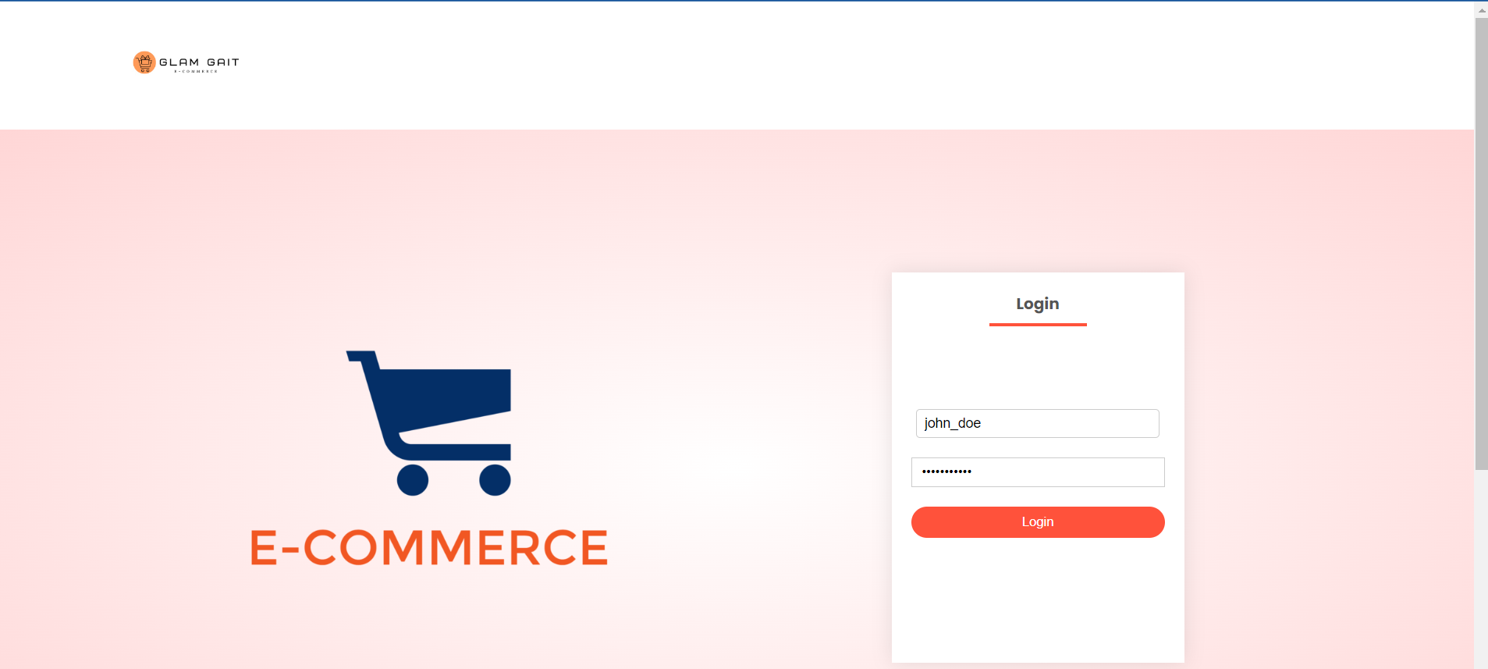

1. Click on the "Sign In" button.

Expected Behaviour:

* If the user is a seller:
  + After successful sign-in, verify that the user is redirected to the seller's main page.
  + Confirm that the URL or displayed content indicates the seller's interface.

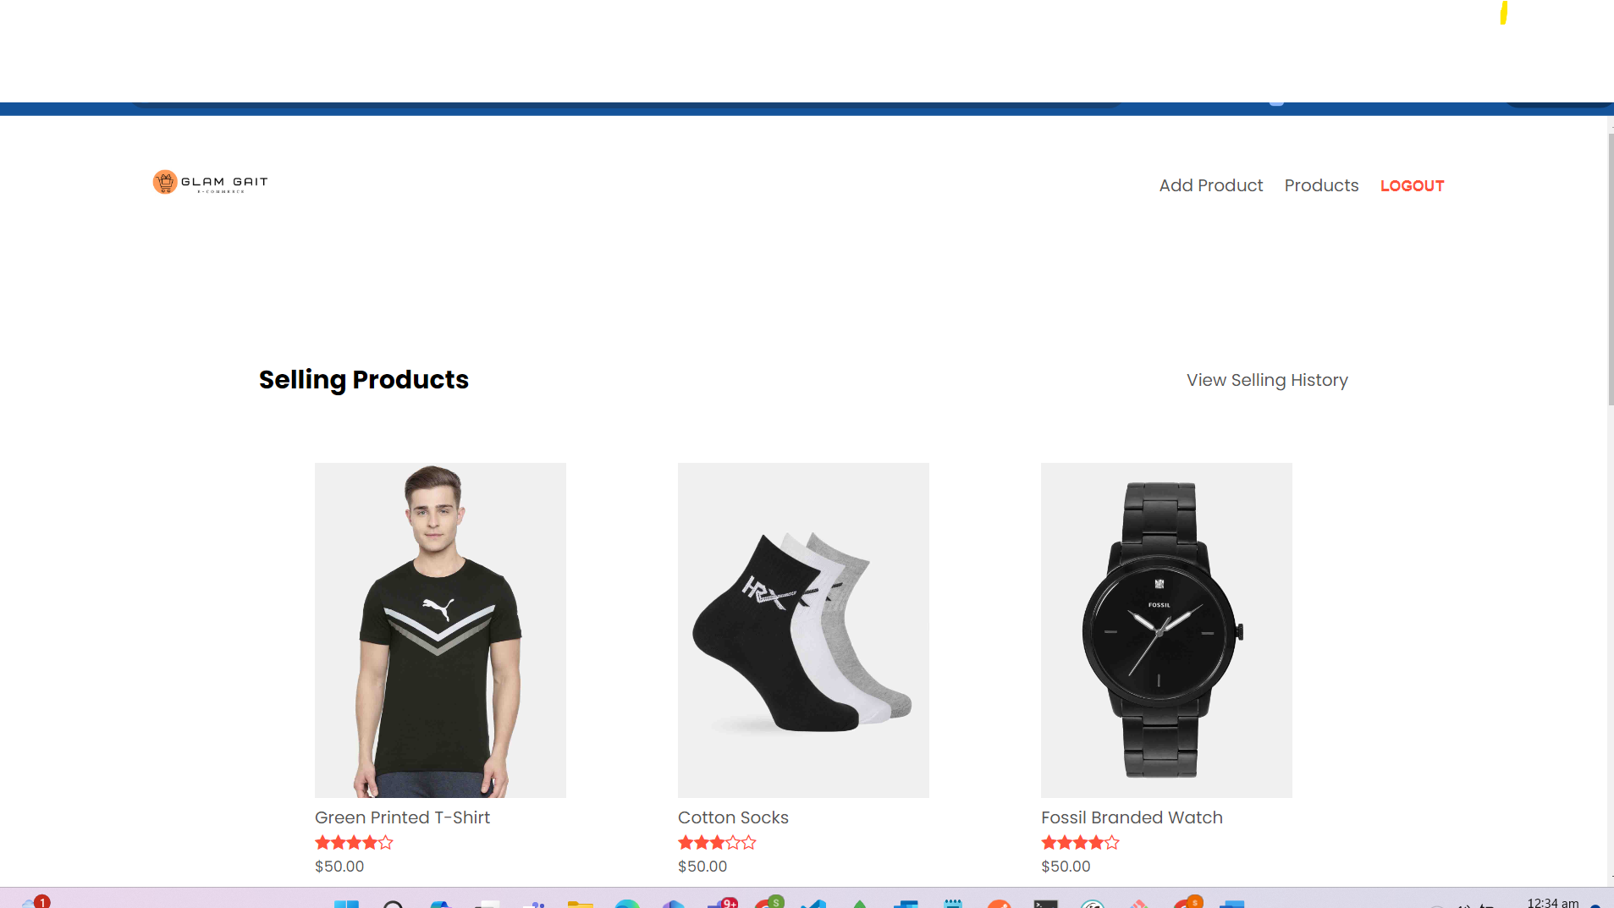

* + If the user is a buyer:
  + After successful sign-in, verify that the user is redirected to the buyer's homepage or main page.
  + Confirm that the URL or displayed content reflects the buyer's dashboard.

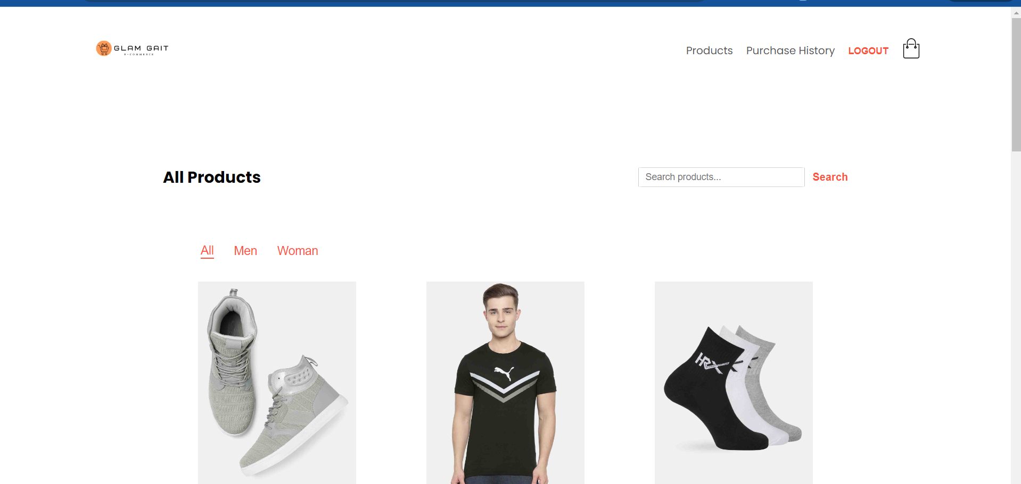

**Test Case: Search Items by Name or Type**

**Objective:** Validate the functionality of searching items by name or type (category) on the e-commerce platform.

**Preconditions:**

1. The application is accessible and the user is logged in.
2. The search functionality is available and visible on the homepage or designated search page.

**Test Steps:**

**Scenario 1: Search by Item Nam**

1. Navigate to the homepage or designated search page of the e-commerce platform.
2. Locate the search bar/input field
3. Enter a specific item name in the search field.
4. Click on the search button/icon or press "Enter" on the keyboard.

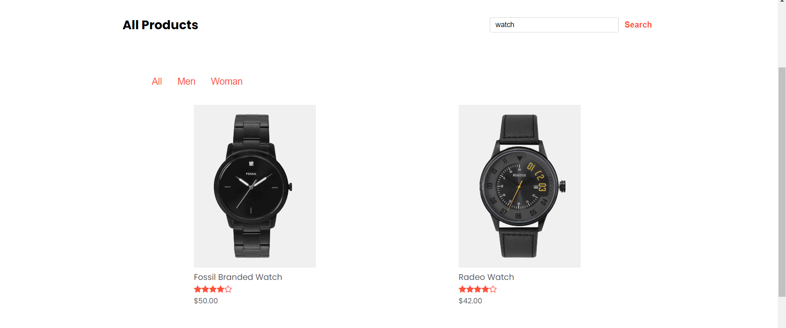

**Expected Behavior:**

* The search results page should display items matching the entered item name.
* Verify that the displayed items' names contain the searched keyword ("Running Shoes").

**Scenario 2: Search by Item Type (Category)**

1. Select a specific item type/category
2. Click on the search button/icon or press "Enter" on the keyboard.

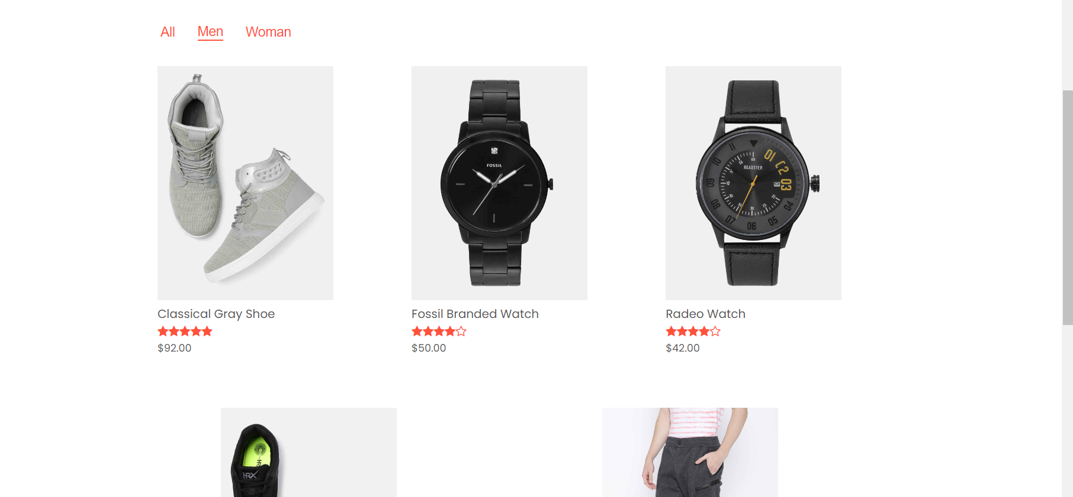

**Expected Behavior:**

* The search results page should display items categorized under the specified type.

**Test Case: Seller Posts Item for Sale**

**Objective:** Verify that a seller user can successfully post an item for sale with specified details (quantity, price, category) on the e-commerce platform.

**Preconditions:**

1. The seller user is logged in to their account on the e-commerce platform.
2. The seller has access permissions to add and manage items for sale.

**Test Steps:**

1. Navigate to the "Sell" or "Add Item" page on the e-commerce platform.

**Step 1: Enter Item Details**

2. Enter the following details for the item:

* **Item Name:** [Enter a unique item name]
* **Quantity Available:** [Enter a valid quantity available for sale]
* **Price per Unit:** [Enter a valid price for the item]
* A screenshot of a computer

  Description automatically generated**Category:** Select the appropriate category for the item

**Step 2: Submit the Item**

3. Click on the "add Product" button to add the item for sale.

**Expected Behavior:**

* The recently added item should be listed among the seller's items for sale.
* 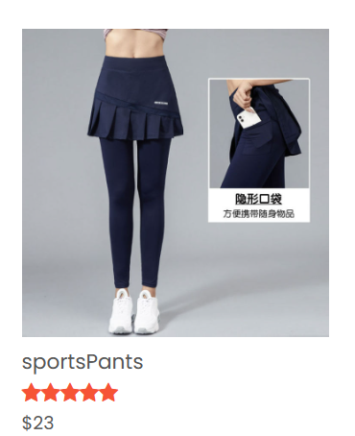The item details (name, quantity, price, category) should match the information entered during item posting.

**Test Case: Buying an Item and Completing Checkout**

**Objective:** Validate the process of buying an item from the e-commerce platform by selecting an item, specifying quantity, adding to cart, entering shipping details, and completing the checkout process.

**Preconditions:**

1. The user is logged in to their account on the e-commerce platform.
2. The user has navigated to the item listing page or search results page.

**Test Steps:**

**Step 1: Select and Add Item to Cart**

1. Navigate to the desired item listing or search results.
2. Click on the item to view its details.
3. Specify the desired quantity for purchase.
   * **Item:** [Select a specific item]
   * **Quantity:** [Enter a valid quantity to purchase]

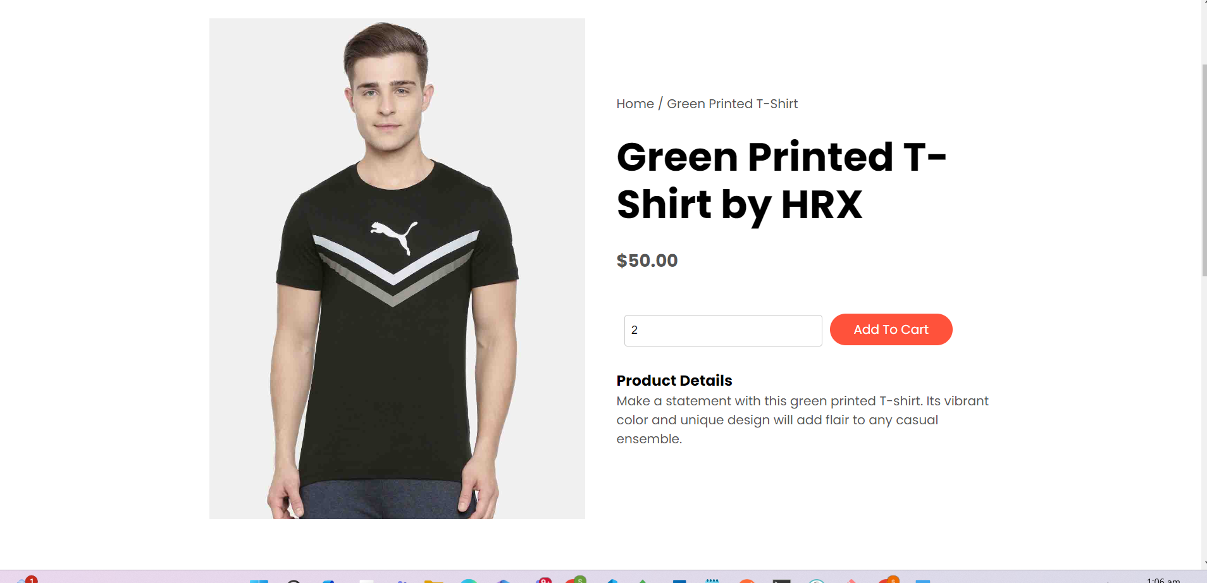

**Expected Behavior:**

* The item details (name, price, image) should be displayed accurately.
* The user should be able to input and confirm the quantity for purchase.
* The selected item with the specified quantity should be added to the user's shopping cart.

**Step 3: Enter Shipping Details**

5. On the checkout page, enter the required shipping details:

* **Shipping Address:** [Enter a valid shipping address]

**Expected Behavior:**

* The shipping form should accept and validate the entered details (address, contact information).

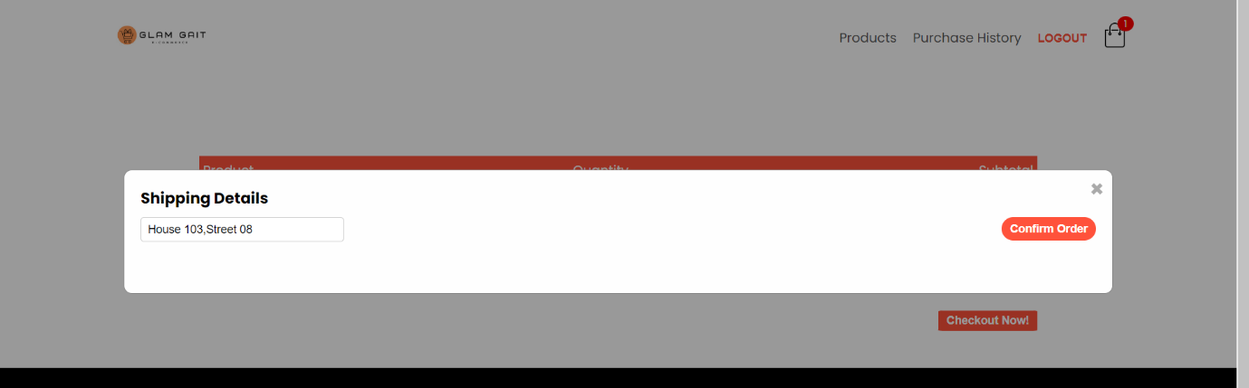

**Step 4: Complete Order**

7. Click on the "Confirm Order" button to finalize the order.

**Expected Behavior:**

* The system should process the order successfully and provide an order confirmation.

**contribution of every member:**

Database Design and Implementation: Reham led the data model design, while Kholoud and Fatma focused on setting up and configuring the database. The team collaboratively implemented seed.js to populate the database, a task that required joint effort due to its complexity.

APIs and Data Repository: Kholoud created the APIs with NextJS, while Fatma created the data repository using optimized Prisma Client queries. The integration of these APIs with the database required a collaborative effort, particularly when developing and running sophisticated queries.

Statistics Use-Case Development: Fatma oversaw the building of the statistics page in React, while Reham and Kholoud provided the necessary data queries. This component's integration into the program involves the entire team, guaranteeing flawless data aggregation and interface functioning.

Testing and documentation: Each member extensively tested their own components. Reham created the documentation, which included test cases and detailed descriptions of our data model and UI designs. The entire team evaluated the final report to ensure that it was thorough and accurate.

**Grading Rubric:**

10

5

25

40

20

100

5